EXPERIMENT 3: NETWORK SECURITY ESSENTIALS

AIM

To learn basic network security concepts and analyze logs to detect attacks like scanning, brute force, and data exfiltration.

PROCEDURE

- Study network security and monitoring concepts.
- Analyze firewall, IDS/WAF, and VPN logs.
- Identify suspicious activities such as port scans and failed login attempts.
- Correlate logs to trace attack stages (recon -> access -> exfiltration).

QUESTIONS

TASK 1 - Network Perimeters: Monitoring and Protecting

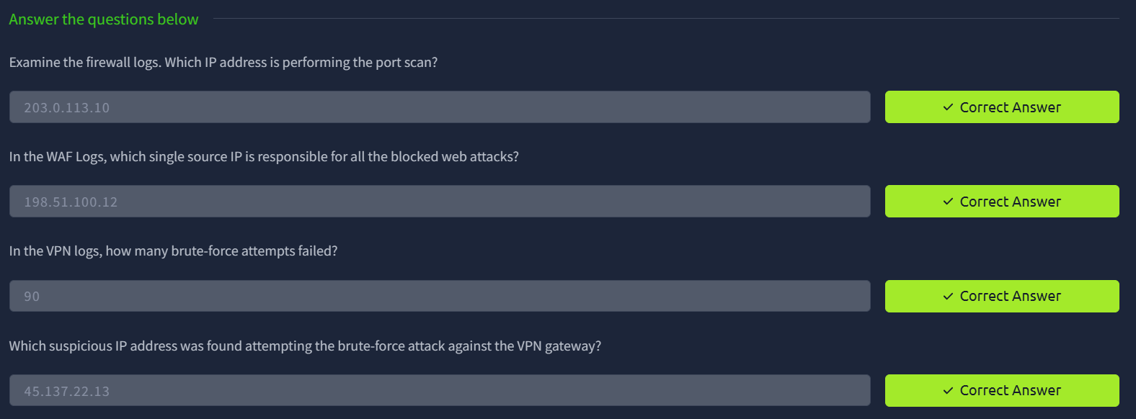

TASK 2 - Perimeter Logs: Investigating the Breach

RESULT

Successfully detected malicious activities and understood how network logs help identify and prevent cyber attacks.

